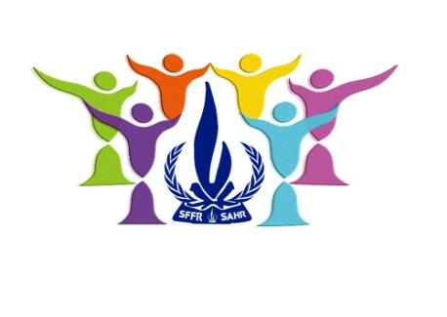
Spring Free From Racism
Saskatchewan Association on Human Rights Inc.
Is hosting a Fundraiser
Featuring a 10 course meal at
China Liang’s
Location: 1700 Broad Street
Date: Thursday November 2, 2017
Cocktails: 5:30 pm
Supper: 6:30 pm
Cost $30.00/person or $300.00/Corporate table
Silent Auction, 50-50’s and Penny Bags
For tickets or additional information please contact Barb Dedi at 306-537-9509 or email: barbadedi@hotmail.com

