**International Women’s Day Event**

Communities in Action: Ending Violence Against Women

“**Strength & Resilience of Indigenous Women”**

through stories, art, song, flea market

Come hear women tell their story.

**March 3, 2017**

Martin Collegiate

11 McIntosh Street, Regina

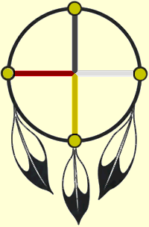

7:00 p.m.

Tea & Bannock

Sponsored by National Farmers Union and

Tatanka Boutique

