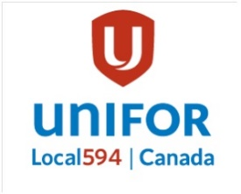 | Unifor Local 594 Merchandise

Merchandise can be purchased each month before and after Executive and General Meetings. Meetings run 5 pm to 6 pm.
Cash Only.
Executive Meetings are the 3rd Tuesday of each month.
General Meetings are the 4th Tuesday of each month, except December.
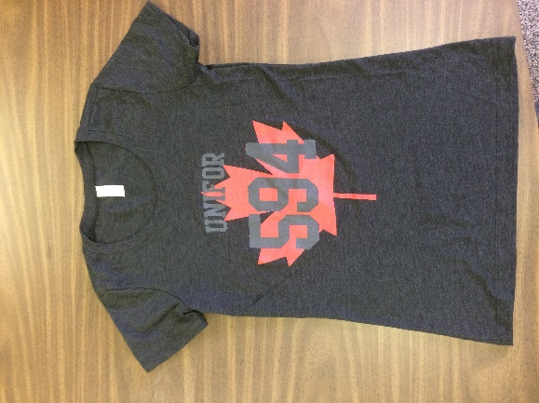 |  | T-Shirt: Maple Leaf | $20 | Men Sizes: M, L, XL & 2XL  Women Sizes: M & L
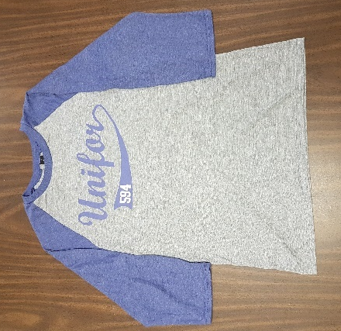 |  | Baseball Shirt | $25 | Sizes: S, M, L, XL & 2XL  Same cut for Men & Women
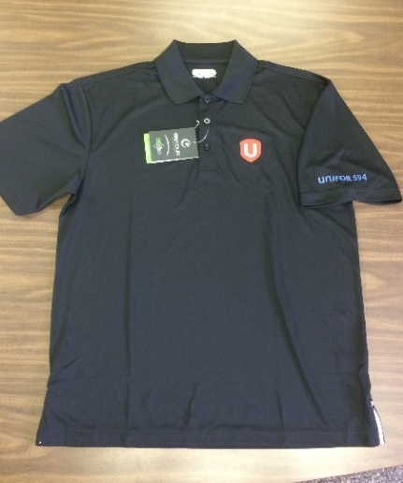 |  | Polo Shirts | $35 | Sizes: M, L, XL & 2 XL  Same cut for Men & Women
Womens  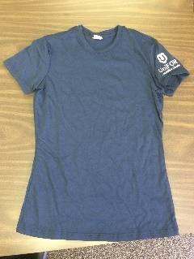 | 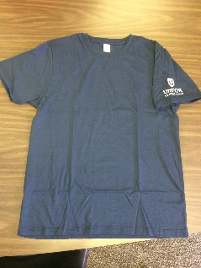  Mens | T-Shirt: Emblem on Sleeve | $20 | Men Sizes: M, L, XL, 2XL & 3XL  Women Sizes: XS, S, M, L
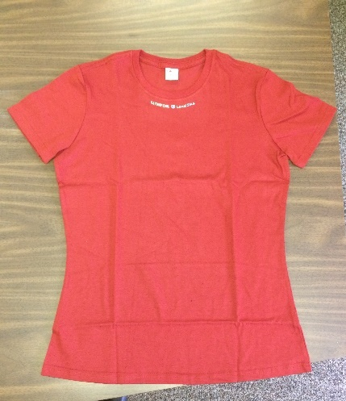 |  | T-Shirt: Emblem on Collar | $15 | Only Women Sizes:  Blue: M & L  Red: M & L
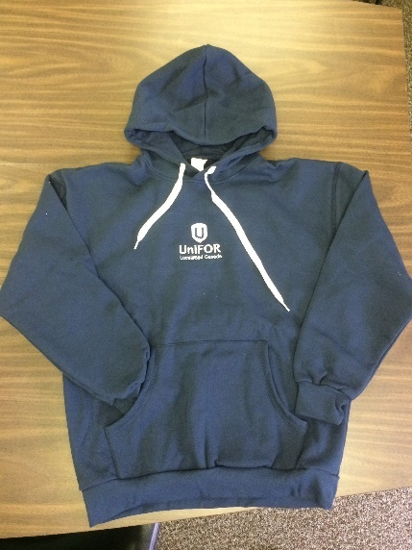 |  | Bunnyhugs | $45 | Sizes: XS, S, L & XL  Same cut for Men & Women
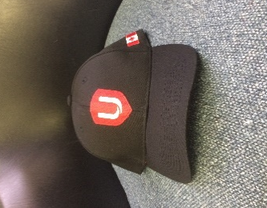 | 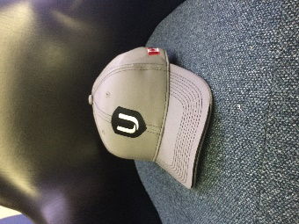 | Ball Caps | $10
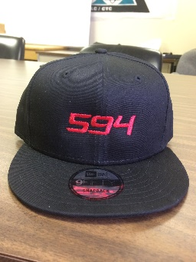 | 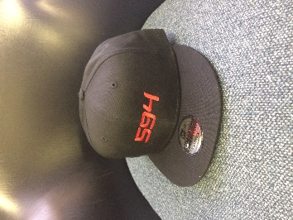 | Flat Bill Caps | $20 | Center Logo  Offset Logo: Out of Stock
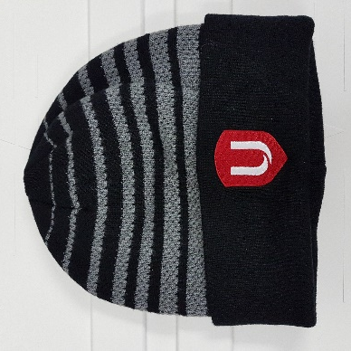 |  | Toques | $10
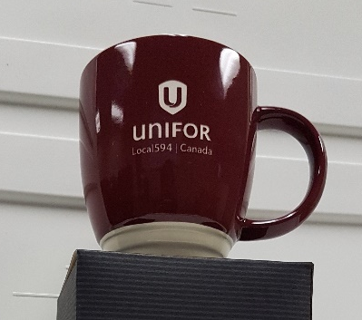 |  | Coffee Mugs | $15
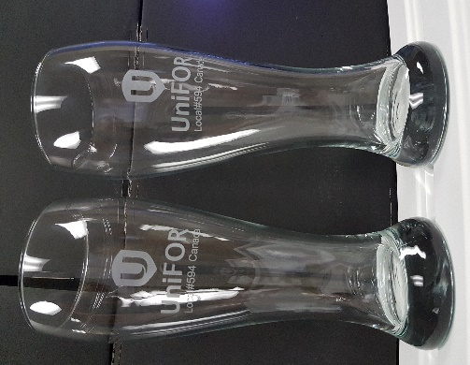 |  | Beer Glasses | $20 | Set of Two
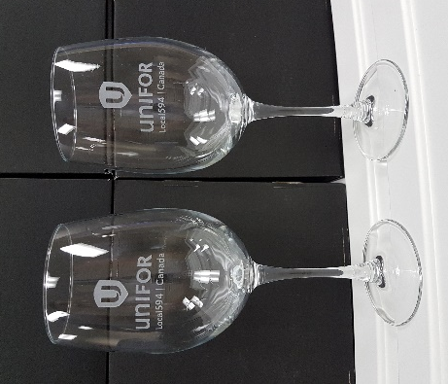 |  | Wine Glasses | $20 | Set of Two
No Picture Available |  | Tumblers | $20 | Out of Stock
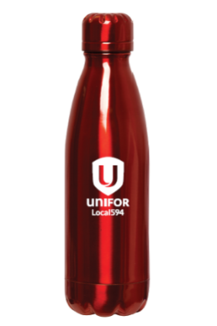 |  | Water Bottles | $15

