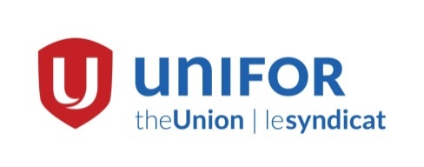

Media Advisory
Unifor to offer solidarity to TTC union
TORONTO, February 7 – As part of its effort to advance a united labour movement, Unifor will make a statement and offer solidarity to the TTC union that is dealing with an American take over.
“Unifor supports and defends the principles of democracy and democratic governance for every union and we are incredibly troubled by the aggressive tactics that the ATU international body has used against Local 113 that represents Toronto transit workers,” Unifor National President Jerry Dias said. “Democracy is a cornerstone of the labour movement.”
The Toronto Transit union, Local 113 was placed in trusteeship by its American affiliate on Friday February 3 after the Local filed a complaint with the Canadian Labour Congress. The media conference will include both President Dias and the President of Local 113, Bob Kinnear.
- What: Media briefing.
- Where: Sheraton Hotel, in the Wentworth Room at 123 Queen St. West, Toronto.
- When: Tuesday, February 7, 11 a.m. to 12 p.m.
- Who: Unifor National President Jerry Dias, Local 113 President Bob Kinnear and more.
- Why: Unifor offers support and solidarity to Local 113 in its plight for democratic representation.
There will be brief opening statements from Dias and Kinnear, followed by a question period for the media. The conference will be livestreamed via Periscope on Unifor’s Twitter account, please follow @UniforCanada.
“Unifor is a social union. Our concerns extend far beyond the shop floor and the bargaining table, this is about democratic representation,” Dias said.
Unifor is Canada’s largest union in the private sector, representing more than 310,000 workers, in every sector of the economy. It was formed Labour Day weekend in 2013 when the Canadian Auto Workers and the Communications, Energy and Paperworkers union merged. For more information please visit unifor.org.
-30-
For more information, please contact Unifor Communications Director, Denise Hammond at denise.hammond@unifor.org or (cell) 416-707-5794.

